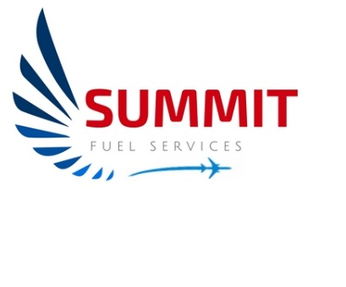

Emergency response Plan

vER 25.10

CYKF

4881 Fountain St N

Introduction 5
Overview 5
Annual ERP Review Record 6
Training 7
Sign Off 8
List of Effective Pages 9
HEALTH AND SAFETY 10
Contact Sheet 11
World Fuels Contacts 11
Role and Responsibilities 15
Initial Notification 16
Security Systems 16
Fencing & Gates 16
Exterior Lighting 17
CCTV 17
Intrusion alarms 17
Law Enforcement Support 17
Threat Levels 19
False Alarms 21
List of Emergency Response Equipment On-Hand 22
Equipment on Board Trucks 22
Equipment Required at the Facility 23
Site Drawing 24
Fueling Areas 25
Apron 1 25
T Hangars Northwest 25
Apron 2 26
Waterloo Wellington Flight Centre 26
Apron 3 27
Waterloo Region Main Terminal 27
Apron 4 28
West T Hangars 28
Apron 5 29
South Hangar Line 29
Apron 7 30
North Hangar Line 30
Emergency-Specific Scenarios 31
Spills During Aircraft Refueling – Main Apron 32
Major Spills During Aircraft Fueling – Ramp 33
Major Spills During Refueller Loading 34
Major Spills During Fuel Receipts 35
Minor Spills 36
Refueler Rollover 37
Refueler Fires 38
Tank Farm Fires 39
Product Quality 40
Product Shortage 41
Cross Fuelling / Misfuelling 42
Actions to be taken to PREVENT a misfuelling. 43
Mandatory Grade Confirmation 43
Hijack / Hostage / Terrorist Activity 44
Aircraft Incident / Aircraft Down 46
Demonstrations and Riots 47
Break - Ins 48
Robbery / Hold Up 49
Bomb Threats 50
Personal Injury 51
Virus Threat 52
Natural Phenomena 54
Suspicious packages 55
Weather Warnings – Lightning 57
Emergency Phone List 58
AIRPORT 58
SUMMIT FUEL SERVICES 58
WOLRD FUEL SERVICES 58

Introduction

This manual is being established to cover emergency situations involving the handling of fuels and other dangerous materials that are encountered daily.

Overview

The Emergency Response Plan deals with emergencies that may happen at the main tank farm, but also at different locations throughout the airport and any incident that will have an impact on Airport Operations.

We must work closely with the Airport in reporting any situation or incidents as this will also affect the safety of personnel working or transiting throughout the airport.

Feel free to ask any questions to your superior and/or the airport regarding any safety issues you see while working at the airport.

This Manual will also be used with the Airport Emergency Procedures Manual which is located at the main Summit Fuel Services building.

Annual ERP Review Record

 | Date of Review | Supervisors Name | Supervisors Signature
2018 | 13 May 2018 | Brian Finnerty | 
2019 | 21 May 2019 | Brian Finnerty
2020 | 2 Feb 2020 | Brian Finnerty
2021 | 13 Apr 2021 | Brian Finnerty
2022 | 2 Jun 2022 | Brian Finnerty
2023 | 9 Sep 2023 | Brian Finnerty
2024 | 21 Sep 2024 | Brian Finnerty
2025 | 10 Oct 2025 | Brian Finnerty

Training

Knowing the steps to take during an emergency is critical to the safety of customers and employees.
All staff are trained initially on the site Emergency Response Plan upon employment and the Emergency Response Plan is reviewed by all employees annually. A current employee sign off sheet is located after this page.
A permanent record of all training sessions is kept on file. Records include names of employees trained, dates, content of training sessions and employees’ signatures, verifying that they have received and understood the information.
This review includes the capability to carry out the responses to the various scenarios outlined in the Emergency Response Plan, including:
• Knowledge of emergency shut-off switches and valves, site drainage and any spill prevention systems,
• Location and operation of fire extinguishers,
• Safe handling practices, including product knowledge / hazards,
• Knowledge of authority for clean-up actions / expenditures and public / media comments,
• Disposal procedures for spilled products and debris (must be done in accordance with strict government regulations),
• Good operating practices for prevention of spills,
• Workplace Hazardous Materials Information System (WHMIS)
• Transportation of Dangerous Goods (TDG)
• Fire Extinguisher (Refresher) training annually as per Transport Canada CSA-B836 and NFPA 10.

As a minimum, one tabletop or physical simulation exercise will be completed each year with simulation scenario, learnings, and employee participation documented in the site training file.

Sign Off

Sign off cover: Emergency Response, Misfuelling Procedures and Spill Drill

Employee | Employee Signature | Date of Review | Supervisors Signature
Sean Young |  | 21 Sep 2025
Mandl, Peter | 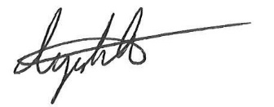 | 21 Sep 2025 | 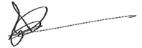
Mayne, Jenna | 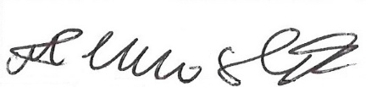 | 21 Sep 2025
Rauf, Izhaan | 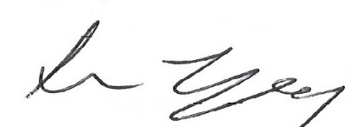 | 21 Sep 2025
White, Thomas | 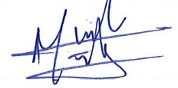 | 21 Sep 2025
Ayres, Glen | 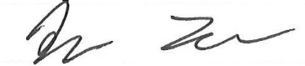 | 21 Sep 2025
Cockburn, Rylan |  | 21 Sep 2025
Dang, Frank | 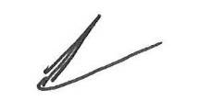 | 21 Sep 2025
Hopkins, Ruby | 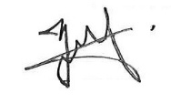 | 21 Sep 2025

Sign off cover: Emergency Response/Misfuelling/and Spill Drill

List of Effective Pages
Ver | Page | Date | Notes
Ver. 18-03 | Page 11 | 7 Sep 2018 | Updated Trained Employees
Ver. 18-03 | Page 12 | 7 Sep 2018 | Updated Public Notification
Ver. 18-03 | Page 35 | 7 Sep 2018 | Actions to be taken to PREVENT a misfuelling
Ver. 18-03 | Page 38-39 | 7 Sep 2018 | WFS document GPO-S-Z918
Ver.19.06 | Page 10 | 15 Jun 2019 | Updated Trained Employees
Ver.20.02 | Page 10 | 20 Feb 2020 | Updated Trained Employees
Ver.20.02 | Page 7 | 20 Feb 2020 | Updated Contact Information
Ver.20.02 | Page 46 | 20 Feb 2020 | Updated Virus/Contagious Threat
Ver.20.05 | Page 46 | 29 May 2020 | Updated Virus/Contagious Threat
Ver 21.05 | Page 5 & 11 | 1 Apr 2021 | Updated Trained Employees
Ver 23.09 | Page 8 | 8 Sep 2023 | Update Employee List
Ver 24.09 | Page 8 | 21 Sep 2024 | Update Employee List
Ver 25.10 | Page 8 | 10 Oct 2025 | Update Employee List

HEALTH AND SAFETY

Product Hazards Identification

Always identify the product and its hazard prior to entering the emergency site.

JETA-1 AVGAS

TDG UN1863 UN1203

TDG Class 3.3 Class 3.1

WHMIS Class B&D Class B&D

Contact Sheet

Airport Operations 1-519-648-3370

Airport Fire Hall 1-519-648-2256 Emergency EXT# 8511

Security 1-519-648-2256 Emergency EXT# 8520

Flight Service Station / Tower 1-519-648-3055

Canutec 1-613-996-6666 / *666 Cellular

World Fuels Contacts

Greg Lang Sr. Operations Manager (519) 999 2864 grlang@wfscorp.com
Jim McPhaul Manager, Fleet and Facilities (903) 277-3929 jmcphaul@wfscorp.com
Bonnie Bhalla Director – Canada Sales (514) 817-3396 bbhalla@wfscorp.com
Paul Frenette Operations Specialist ()902) 580-0055 pfrenette@wfscorp.com
Wayne Ference Sales Executive (780) 910-5566 wference@wfscorp.com
Elizabeth Tessier Sales Executive (514) 968-7495 etessier@wfscorp.com

When to Call the WFS 24hr Emergency Number

• When you need to report a serious incident has occurred at your site and you cannot reach your Account Executive or Facility Specialist.
• When you are unclear about how to proceed in responding to a local site incident or emergency.
• The first phone calls you make should be to your local emergency responders as outlined in your local Site Emergency Response Plan.

General Site Safety and Security

• Rope off hazard areas
• Eliminate all ignition sources
• Do not flush product into waterways sewers
• Move injured persons to fresh air
• Take care when excavating for buried cables and underground pipes
• Have any personnel contaminated by product, transported to shower immediately. Available at Fire Department.
• Authorized personnel have access to spill site. All others must be evacuated.
• Avgas Farm is Tanks 1 & 2 have a max capacity of 35,000L and a max fill capacity of 33,000L
• Spill Kits are located on the driver’s side of each truck in a box labeled “SPILL KIT”
• Spill Kit at the Tank farm is a brown bench labeled “SPILL KIT” There are also brooms, and shovels on each truck and at the tank farm

Personal Protective Equipment

When handling spilled material, WEAR the following personal protective equipment as a minimum:
• Safety Glasses
• Safety Shoes/Boots
• Petroleum Resistant Gloves
• Bump Cap or Hard Hat
• High Visibility Clothing or Vest

If additional personal protection is needed:
• Rain suit if clothing contamination is likely to occur
• Goggles or face shield if liquid splash can occur

Containers with Spilled Materials

All containers of spilled material should be labeled with:
• WHMIS label
• Name of material
• Type of hazard
• Date / Time collected
• Location collected from

Handling Flammable Liquids
• Flammable liquids auto-ignite on hot surfaces.
• Vapors are ignitable by ignition sources.
• Movement of liquid generates static electricity.
• Ensure all equipment used to transfer product is bonded and grounded.
• Use continuity meter to confirm grounding and bonding.
• Use non-sparking tools and explosion proof flashlights.
• Flammable liquids may be lighter than water and so will tend to float on the surface.
• Vapors are heavier than air. Vapors will remain at ground level and will collect at low areas such as ditches.
• Runoff too severe may cause fire or explosion in surrounding areas.

MSD Sheets attached in binder.

Role and Responsibilities

Justin Labelle is the General Manager of Summit Fuel Services at the Region of Waterloo International Airport. He is also responsible to ensure the emergency plan is complete and accurate.

The Lead Hand is responsible to ensure all line crew receive initial and recurrent training of the emergency response plan. He is also responsible to conduct at minimum, one tabletop exercise per year, covering all aspects of the emergency plan. He is responsible to coordinate with various organizations/individuals in the event of an emergency.

World Fuel is the owner of the fuel storage on site and leases the land where the fuel farm is located at the Region of Waterloo International Airport. The World Fuel Facility Specialists listed in this Emergency Response Manual are the responsible representative of World Fuels for the fuel storage system locate at the Region of Waterloo International Airport.

Summit Fuel Services line crew are responsible to be familiar with and carry out the procedures in the Emergency Response Plan.
Current Trained Employees
- Brian Finnerty Oversight
- Sean Young Lead Hand
- Mandl, Peter
- Mayne, Jenna
- Rauf, Izhaan
- White, Thomas
- Ayres, Glen
- Cockburn, Rylan
- Dang, Frank
- Hopkins, Ruby
- Whitt, Adrian

The above employees of Summit Fuel Services Service These employees receive training in:
- (M)SDS (WHMIS 2015)
- Transportation Dangerous Goods
- Fire Extinguisher and Fire Safety
- Aviation Fuel Training – 360 Training
- Safety Training
- Participate in Spill Response and Review of Emergency Response Plan
- Human Factors

Initial Notification

Line crew are responsible to initiate the emergency plan by taking steps which are safe for them to perform and by calling 911. They are in charge of the situation until such time as the Airport Fire Department and Region of Waterloo Police arrive on site and take control of the situation. At the time, Summit Fuel Services employees remain available to provide support and assist in whatever areas are required.

The Region of Waterloo International Airport Operations personnel and the World Fuels Service’s 24-hour Response Centre are all responsible to assist in the event of an emergency by providing resources and expertise.

Public notification
The need for public notification, and any actual public notification, will be identified and carried out by the emergency responders and/or the authorized person.

WFS notification
WFS shall be notified by the Dealer’s employees as soon as possible (same day) once the local Dealer’s employees are freed up by the emergency response crews.

Assistance
The Region of Waterloo International Airport Operations airport personnel, the Region of Waterloo Police and Fire Emergency Management Teams, CANUTEC, and WFS’s 24-hour Response Centre are all available to assist in the event of an emergency by providing resources, information and/or expertise.

Security Systems
The Airport utilizes a number of security systems designed to help fulfill its security mission. These systems complement the policies, procedures, and measures that form the Airport's robust security program. The Airport's security systems include:

Fencing & Gates
Fencing is the first layer of security at all of our facility, Transmission/Distribution points, and Airport facilities. The Airport has standardized on 8-foot fencing, using tension wire in lieu of bars, placing fence barbs up, and securing the bottom of the fencing at grade. Access points/gates are secured through one of the following methods: Manually opened and secured with a heavy duty Airport approved pad lock, key pad or electronically accessed with card credential, or electronically accessed with remote gate fob/RAIC Card. All perimeters and access points are monitored 24/7 by CCTV or contracted security guards.

Exterior Lighting
Exterior lighting has been strategically placed throughout the Airport to emphasize and highlight perimeters, gate and Guard Post access points, entry points into buildings, and areas of interest. Lighting can be activated by motion or photocell. Exterior lighting serves as a deterrent, as well as to aid in monitoring of the Airport's CCTV system.

CCTV
The Airport has deployed over 25 CCTV cameras. These cameras have Pan/Tilt/Zoom (PTZ) capabilities and are strategically placed throughout the projects. Via our unique Fiber Optic infrastructure, these camera signals are sent back centrally to the Airport's headquarters office where they are recorded 24/7. From this central point, Security has the ability to monitor and control all cameras.

Intrusion alarms
Intrusion alarms are utilized throughout the Airport. These alarms serve two important functions:
• Provide 24/7 monitoring in remote locations where staff is not always present.
• Installed in all CIP-designated spaces. The alarm sensors include door/window contacts, motion detection, and glass break.
These Intrusion alarm systems are monitored 24/7.
Security Guards

The Airport contracts the services of a private security company. Guards are stationed at the Main Terminal. Additionally, "patrol" guards are assigned to conduct security checks of the Airport's properties.

Law Enforcement Support
The Airport has developed strong partnerships with the local law enforcement agencies. These agencies support the Airport's security mission through collaborative training & exercises, observation patrols, response to incidents, and proactive meetings.

Threat Levels

GREEN - BLUE - ORANGE – RED

Physical Response Guideline for Threat Alert Level

GREEN (Low)

• Normal security operating standards and procedures.
• General workforce safety awareness in place.
• Emergency Response Plans in place and annual review as a minimum.

BLUE (Guarded)

• Work force alert to unusual activities and whom to report such activities.
• Operational plans and procedures up to date, to include:
Security, Threat, and Disaster Recovery plans in place and reviewed.
Other Operation Plans as appropriate, i.e., Radio Checks, Phone Checks etc.
Determine availability of additional security personnel.
Determine responsiveness of medical emergency personnel.
• Review all data and voice communications channels to assure operability, user familiarity, and backups function as designed.
• Review Emergency Response Plans.
• Ensure all gates, security doors, and security monitors are in working order and visitor, contractor, and employee access control is enforced.
• Identify critical and on-call personnel.
• Establish communications with Lead Hand and Summit Fuels Services Manager.

ORANGE (High)

• Place all critical and on-call personnel on alert, consider tabletop exercises.
• Ensure all gates and security doors are locked and actively monitored either electronically or by "random walk-by procedures".
• Implement enhanced screening procedures for personnel and deliveries.
• Limit access to facilities to essential personnel.
• Coordinate with fuel suppliers, as necessary.
• Inspect site fuel storage and HAZ-MAT (hazardous material) facilities.
• Increase liaison with Lead Hand and Management.
• Coordinate critical security programs with adjacent utility organizations.
• Consider emergency utility operations/procedures appropriate to available threat intelligence.
• Additional business/site specific measures as appropriate.

RED (Severe)

• Implement measures GREEN, BLUE, YELLOW, and ORANGE.
• Establish contacts with security, medical or Lead Hand depending on emergency.
• Secure all entrances and critical service facilities.
• Stop all mail and package deliveries directly to site.
• Stop all vehicles entering site.
• Fully brief all personnel on emergency procedures.
• Establish frequent communications with medical or Lead Hand depending on emergency.
• Review plan for returning to Threat Level - ORANGE, YELLOW, BLUE, or GREEN status.
• Additional business/site specific measures as appropriate.

False Alarms

All alarms will be investigated by the division or personal that instigated the report. If an alarm sounds, follow the proper procedures in this manual in all respects.

If you are the individual who has sounded a false alarm, and you are working as part of a crew, notify the lead hand or shift supervisor immediately.

If you are the Lead hand or the shift supervisor, notify Airport Security as soon as possible using the attached phone list.

List of Emergency Response Equipment On-Hand

Equipment Required On-hand at Each Site

In order to be prepared to contain and recover a spill, response equipment must be readily available. Synthetic sorbent pads are recommended as they can be wrung out and reused thereby reducing disposal amounts and costs.

Equipment on Board Trucks

Trucks should have on board:

• 1 shovel, straight blade, aluminum
• 25 sorbent pads, 50 cm x 50 cm x 1 cm (3/8") thick or equivalent roll
• 1 Buna N drain stopper (120 cm x 100 cm x 0.32 cm thick) to cover sewer catch basins
• 1 - 22 litre plastic bucket with granular oil absorbent
• 1 oil sorbent boom (3 metres long)
• 1 pair oil-resistance gloves
• 2 heavy-duty polyethylene bags (70 cm x 45 cm x 4 mil used pad storage)
• 1 - 2.25 kg A/ B/ C fire extinguisher in cab
• 2 - 9 kg (2 x 4.5 kg) B / C fire extinguishers at accessible location on unit

Equipment Required at the Facility

The following equipment should also be available at tank farm locations. This equipment can contain and clean up approximately a 150 – 200 litre spill. Depending on the volume throughput, the area affected by a spill, etc., additional equipment may also be considered:

• 1 shovel, straight blade, aluminium
• 1 spade, pointed blade, steel
• 2 push-brooms
• 75 - sorbent pads: 50 cm x 1 cm (3/8") thick, or equivalent roll
• 3 oil sorbent containment booms, each 3 metres long (75 mm diameter min.)
• 1 - 20 kg bag granular oil sorbent (e.g., “oclanzorb”)
• 1 Buna N drain stopper (120 cm x 100 cm x 0.32 cm thick) to cover sewer catch basins
• 1 litre plug and dyke (granular form)
• 1 - 205 litre clean open-head drum (for storage of recovered product)
• 1 - 205 litre clean open-head drum (for storage of used sorbents & granular material
• 2 pairs of oil-resistance gloves
• 2 heavy-duty polyethylene bags (70 cm x 45 cm x m4 mil used pad storage)
• 1 - 9 kg B/C fire extinguisher for each truck loading and unloading positions

The Region of Waterloo Airport Operations division and the Airport Fire Department also have a supply of sorbent materials, booms, etc. Typically, this material can be used in an emergency and then replaced.

The amount, use, availability and location of the material should be discussed with the Airport Manager as part of the Contingency Plan and documented.

Site Drawing
Main Building & Farm

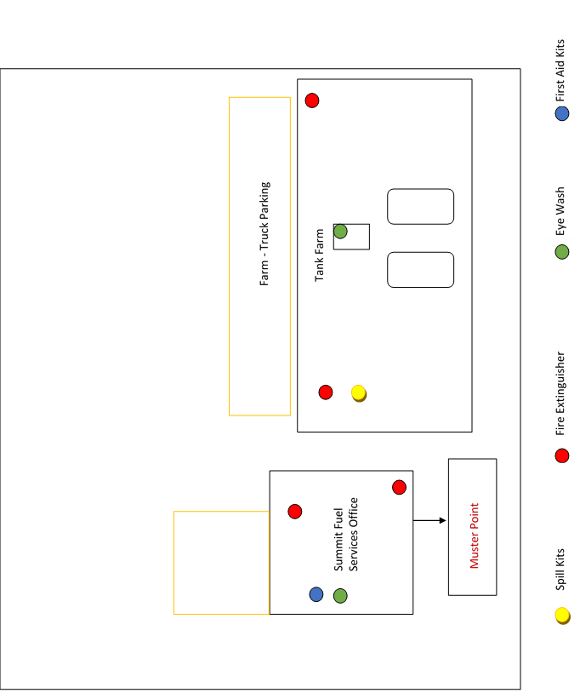

Fueling Areas

Apron 1

T Hangars Northwest

General Description
This area is located on the west side of the airport on Apron 1 and is leased by many private pilots.

Special Considerations
- The Drainage ditch is located east of this location and if any spills were to occur in this area, spill dams should be employed to contain the spill and Airport Operations is to be notified.
- Operations will also notify the hangars occupants if any fuel enters the private hangars.

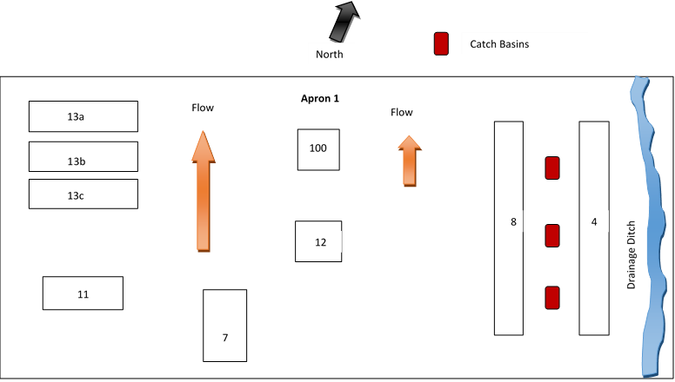

Apron 2

Waterloo Wellington Flight Centre

Main Ramp
This area is located on the west side of the airport on Apron 2 at the intersection of Alpha and Charlie taxiways. The large main ramp is the main operating area for the Waterloo Wellington Flight Centre and is also the location for the main Summit Fuel Services office and fuel tank. Fueling also takes place on Apron 2B for transient aircraft and Air Ambulances and is located just west of the control tower.

Special Considerations
- In the event of a spill, the Apron 2 has two catch basins that must be closed using the keys located on the map below. These catch basins drain to the surrounding drainage ditch and then to the creek that crosses Fountain St N.
- Any spills near the Restaurant will require an immediate evacuation of the patio.

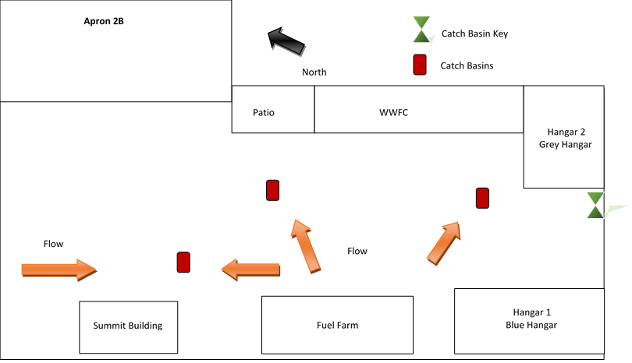

Apron 3

Waterloo Region Main Terminal

General Description
Fueling of aircraft at the main terminal area comprise mostly of commercial heavy jets, and smaller business jet and turbo prop aircraft.

Special Considerations
- There are several catch basins in this area on a mostly flat tarmac.
- This location is also the main transit area for passengers from the main terminal area, so special attention must be maintained in this area at all times.
- Airport Operations can be contacted at any time and will assist you in containing any spills in this area.

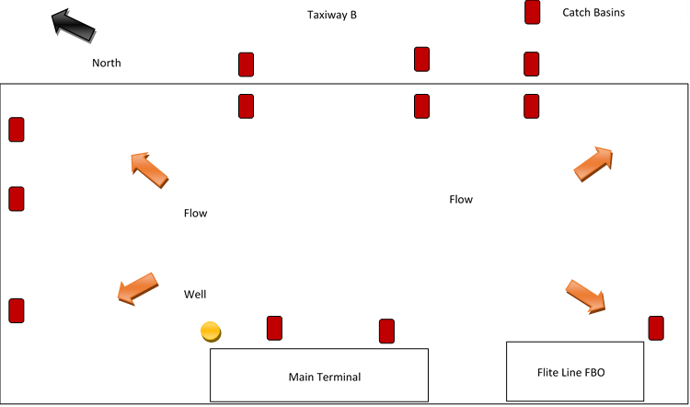

Apron 4

West T Hangars

General Description
This area is located on the west side of the airport along Canuck Rd. The asphalt in front of all of the hangars is very thin and has many cracks and this may result is areas that fuel could seep into the ground.

Special Considerations
- In the event of a spill, there are hidden catch basin in the grass that must be covered

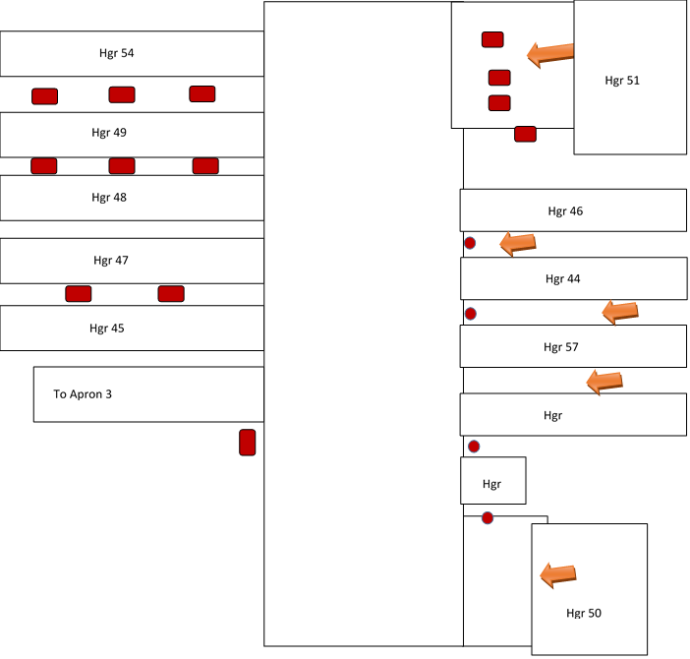

Apron 5

South Hangar Line

General Description
This area is a mixture of private hangars and maintenance hangars.

Special Considerations
- The drainage ditch is located at the southwest end of this location. There are also several storm drains located throughout this area.

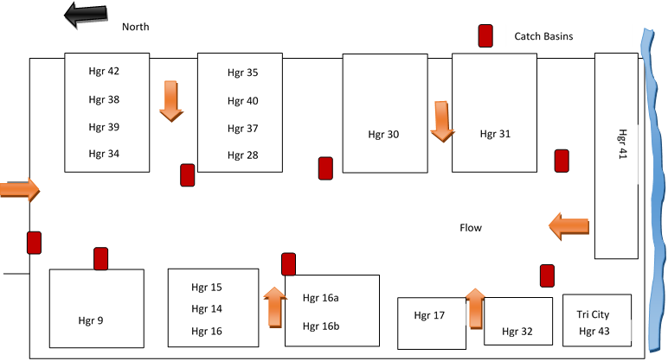

Apron 7

North Hangar Line

General Description
This area is a the FBO for Chartright

Special Considerations
- The surface here is concrete, so any spills will move faster than in other areas. There are also several storm drains located throughout this area.
- Fueling is done here primarily Avgas.
- Also, be aware that there is a Jet fuel farm at this location with spill gear if needed.
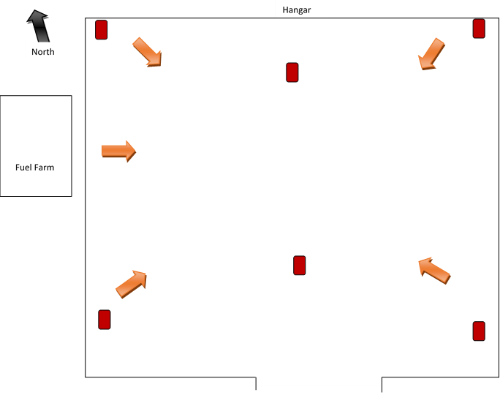

NEVER place the safety of personnel in jeopardy, whether by threat of fire, explosion, or hazardous environmental conditions.

Emergency-Specific Scenarios

Emergency-Specific Scenarios section provides additional information regarding the response to a particular hazard or emergency situation. This detailed information within this manual is located in each fuel truck, the fuel testing area (fuel hut) and the main entrance to the Summit Fuel building.

A tabletop review will be conducted every year of the emergency and security plans. Updating the plans, revising procedures, and possibly playing out a scenario to recognize local challenges can be part of the review event. The objective is to maintain and improve the plans and agency coordination.

NEVER place the safety of personnel in jeopardy, whether by threat of fire, explosion, or hazardous environmental conditions.

Spills During Aircraft Refueling – Main Apron

- Stop the flow of product by releasing deadman.
- Activate the emergency shutoff on truck.
- Immediately notify the pilot to evacuate the aircraft. Also notify your supervisor.
- Eliminate all sources of ignition.
- If mobile fueling equipment, ground equipment have engines running, do not shut off engines or do not start any engines. This could provide a spark or ignition source. The Fire Department may foam the area if required. When it is safe to do so, tow or push vehicles from the area.
- Evacuate all unauthorized personnel.
- Place drain cover over sewer drains or lock drains so that product may not flow into them . Pile earth on top of drain cover to weigh it down. If the site contains a separator, close the valve for the separator outflow.
- Restrict access to the spill area. Only emergency personnel and response team should have access.
- Contain the spill. Put on petroleum resistant boots, gloves and goggles when handling product.
- Block off culvert or ditch. Use oil booms, kitty litter, sand, snow etc. to divert and/or corral product away from drains.
- Do not flush product into the sewers because this enlarges the danger area and makes it difficult to eliminate ignition sources.
- Remove refueller from area if it is just outside the spill area.
- In the event of a large spill GET HELP!! Notify previously organized response team WFS and Airport Manager. Upon notification of the Airport Manager, Fire Department, at their discretion they will initiate the Airport response plan. Airport authorities will assign and “ON SCENE CONTROLLER” (OSC). Cooperate with the OSC when responding to the spill.
- Keep product from entering drains and waterways.
- Recover visible product / contaminated materials when it is safe to do so. Use absorbents or vacuum truck to recover visible product. Observe safe operating procedures when doing so. Wring out absorbents into empty drum and reuse the absorbent.
- Dispose of contaminated materials / product. Contaminated soil will require removal and treatment. Ensure that all containers are labeled and placed in a secure area for removal.
- Arrange for proper disposal of wastes generated. Ensure that all waste is stored, transported and disposed of according to provincial/federal waste regulation requirements.
- Ensure that all reports required by applicable government regulations and World Fuel Services policy are filed within the prescribed time limit.
- Notify your WFS Account Executive and/or Operations Specialist same day.
- Reorder and replace any of the spill absorbents and personnel protective equipment used to ensure that you have the required quantities on site to be in compliance with the Site Contingency Plan.

NEVER place the safety of personnel in jeopardy, whether by threat of fire, explosion, or hazardous environmental conditions.

Major Spills During Aircraft Fueling – Ramp

- Stop the flow of product by releasing the dead man or close the butterfly valve on the cabinet if safe to do so.
- Activate emergency shut-off on truck or shut down product pumps at cabinet by pushing “Emergency Fuel Shutoff” button if safe to do so, if not, kill power to pumps at main electrical panel, after completing step 3.
- Immediately notify pilot to evacuate the aircraft.
- Notify Flight Services, Airport Fire Department, and your supervisor.
- Eliminate all source of ignition. Turn off power for tank farm.
- If there is ground equipment in area. DO NOT start or shut off equipment. Fire Department will foam area to minimize vapors. When it is safe to do so, push equipment from area.
- Evacuate unauthorized personnel from spill site.
- Restrict migration of product to sewer drain with oil booms, snow, sand, and earth. Fuel must not leave facility.
- Continue to contain spill.
- Restrict access to spill site.
- GET HELP!
- Recover visible product and contaminated materials when it is safe to do so.
- Use absorbents and or vacuum truck to recover visible product. Place contaminated wastes / product into
- DO NOT allow product to enter water ways or contaminate wells.
- Dispose of product / contaminated materials as per local requirements. Government will monitor removal of contaminated soil.
- Wring out absorbents into steel drums, reuse the absorbents.
- Ensure all containers are labeled and stored in a secure area on site. Arrange for the proper disposal of contaminated wastes generated.
- Complete incident report(s) as required by World Fuel Services and government agencies.
- Cooperate with Airport authorities, government and news media. Give facts, avoid speculation.
- Reorder absorbents and personnel protective equipment.
- Notify your WFS Account Executive and/or Operations Specialist same day.

NEVER place the safety of personnel in jeopardy, whether by threat of fire, explosion, or hazardous environmental conditions.

Major Spills During Refueller Loading

- Stop the flow of product.
- Activate the emergency shut off on truck.
- Shut off product pumps.
- Contain spilled product.
- Cover sewer drain.
- Close all valves in the loading area.
- Eliminate all sources of ignition.
- Shut off all power to the tank farm.
- Evacuate all unauthorized personnel.
- Get Help! Notify airport Fire Department and your supervisor immediately.
- Call 24 Hr Emergency Response WFS Contact Number 1-800-608-0298 if required.
- Airport Fire Department may foam area to eliminate vapors.
- Recover visible product / contaminated materials when it is safe to do so. Use absorbents or vacuum truck to recover visible product. Wring out absorbents into steel drum and reuse.
- Dispose of contaminated materials into open steel drum. Place contaminated soil/materials into steel drum to minimize further contamination of soil. Ensure that containers are labeled and placed in a secure area on the site.
- Arrange for proper disposal of wastes generated. Ensure that all wastes are stored, transported and disposed of according to local requirements.
- Cooperate with Airport, government, and news media authorities. Give facts, avoid speculation.
- Complete incident report as required by World Fuel Services and government agencies.
- Reorder absorbents and personnel protective equipment.
- Notify your WFS Account Executive and/or Operations Specialist same day.

NEVER place the safety of personnel in jeopardy, whether by threat of fire, explosion, or hazardous environmental conditions.

Major Spills During Fuel Receipts

- Stop the flow of product.
- Shut off the emergency shut off valve on tanker.
- Shut off product pump.
- Contain spilled product, cover drain holes in area.
- Eliminate all sources of ignition.
- Shut off power for facility, lock power switches on cabinets.
- Close inlet valves to tank to prevent further spill.
- Restrict access to the spill site.
- Get Help! Notify Fire Department and your supervisor immediately.
- Call 24 Hr Emergency Response WFS Contact Number 1-800-608-0298 if required.
- Airport Fire Department may foam to minimize fuel vapors.
- Contain spilled product. DO NOT allow product to migrate from the facility. Block sewer drain. Use sand, earth, snow and oil brooms to corral product. Do NOT flush product into drain.
- Recover visible product/ contaminated materials when it is safe to do so. Use absorbent or vacuum truck to recover visible product. Wring out absorbent into steel drum and reuse absorbent.
- Dispose of contaminated materials / product into steel drums. Place contaminated soil / material into drum to minimize further contamination of soil. Ensure that containers are labeled and placed in a secure area on site.
- Arrange for proper disposal of wastes generated. Ensure waste is stored, transported and disposed of according to local waste regulation requirements.
- Cooperate with Airport, government and news media authorities. Give facts, avoid speculation.
- Complete incident reports required by World Fuel Services and government agencies.
- Reorder absorbents and personnel protective equipment.
- Notify your WFS Account Executive and/or Operations Specialist same day.

NEVER place the safety of personnel in jeopardy, whether by threat of fire, explosion, or hazardous environmental conditions.

Minor Spills

- Stop flow of product. If refueling aircraft, notify pilot.
- Turn off product pumps.
- Eliminate ignition sources.
- Secure the area.
- If a fire hazard exists, notify Airport Fire Department to stand by. Ensure fire extinguisher is accessible.
- Put on personal protective equipment, if required.
- DO NOT move equipment until it is safe to do so.
- Use absorbents to contain and clean up spilled product.
- Place contaminated materials in labeled containers for disposal. Ensure wastes generated are disposed of according to local requirements.
- Notify supervisor. Notify the appropriate external contacts, if necessary and complete reports.
- Reorder absorbents and personnel protective equipment as required.
- Notify your WFS Account Executive and/or Operations Specialist same day.

NEVER place the safety of personnel in jeopardy, whether by threat of fire, explosion, or hazardous environmental conditions.

Refueler Rollover

- If truck engine is running and it is safe to do so, TURN OFF engine.
- Evacuate people in the area.
- Notify the fire department, airport authorities, police, and your supervisor immediately.
- Call 24 Hr Emergency Response WFS Contact Number 1-800-608-0298 if required.
- If the spill has taken place on the highway, ask a passing motorist to notify the Police and Fire Department. Ask the person to return to confirm doing so.
- Put on petroleum resistant boots, gloves and goggles.
- Supervisor to notify WFS Account Executive and/or Operations Specialist immediately.
- If product is leaking and is safe to do so, PLUG the hole. Use materials in Spill Kit to aid in plugging the hole.
- Use absorbents, earth and snow to contain spilled product. Prevent product from entering into drains.
- The attending response team will have equipment and trained personnel to recover the product from overturned Refueller. Aid the response team as required. After the product has been recovered from the tank, two tow trucks should be used to upright the unit.
- Proceed with cleaning up any spilled product. Arrange for temporary storage on site. Ensure that the containers are labeled and placed in a secure area. Ensure that waste generated is disposed of properly.
- Notify appropriate external contacts and complete required report(s).
- Reorder absorbents and personnel protective equipment.

NEVER place the safety of personnel in jeopardy, whether by threat of fire, explosion, or hazardous environmental conditions.

Refueler Fires

- Shut down all pumping equipment if safe to do so.
- Advise Airport Fire Department and Airport Manager.
- Advise the Fire Department the type of fuel and quantity.
- If minor / small fire, approach from upwind position and extinguish flames using fire extinguisher. Direct the dry chemical at the base of the fire. If large fire, wait for Airport Fire Department.
- If you are fighting a spill fire, extinguish the ground fire first, then direct the chemical at the base of the fire.
- Evacuate personnel from site.
- Restrict all incoming traffic except emergency vehicles. Close gates and doors that may give access to unauthorized personnel.
- Cooperate with Fire Department. Do not attempt to direct the Fire Department firefighting operations. Assist the Fire Department as needed.
- When the fire is out, do not attempt to move the truck or transfer product until it is safe to do so.
- Assist regional personnel in their investigation.
- Ensure all waste generated by any spill are handled, stored, and disposed of in accordance with local / provincial regulations.
- Ensure all reports required by applicable government regulations and WFS company policy are filled within the prescribed time limit.
- Reorder and replace any of the spill absorbents and personnel protective equipment used to ensure that you have the required quantities on site to be in compliance with the Site Contingency Plan.
- Recharge fire extinguishers as required.
- Notify your WFS Account Executive and/or Operations Specialist same day.

NEVER place the safety of personnel in jeopardy, whether by threat of fire, explosion, or hazardous environmental conditions.

Tank Farm Fires

- Shut down all pumping equipment if safe to do so. (Power disconnect including main power shut-off).
- If minor / small fire, approach from upwind position and extinguish flames using fire extinguisher. Direct the dry chemical at the base of the fire.
- Advise Airport Fire Department and Airport Manager.
- Advise the Fire Department the type of fuel and quantity.
- Remove refueler(s) / vehicles to a safe area away from potential fire area and site.
- Evacuate personnel from the area by the planned evacuation routes outlined in the response plan. Once employees are evacuated site manager conducts a head count. If it is determined that person(s) are missing, the person in charge will immediately advise the fire department.
- Advise all other people in the area to stop work and direct them to a safe location.
- Restrict all incoming traffic except emergency vehicles. Close gates and doors that may give access to unauthorized personnel.
- Cooperate with Fire Department. Do not attempt to direct the Fire Department firefighting operations. Assist the Fire Department as needed.
- If you are fighting a spill fire, extinguish the ground fire first, then direct the chemical at the base of the fire.
- Advise the fire department to use hydrocarbon compatible foam, such as AFFF (aqueous film foaming foam) or AFFF / ATC (aqueous film foaming foam – alcohol type concentrate).
- Assist regional personnel in their investigation.
- Ensure all waste generated by any spill are handled, stored, and disposed of in accordance with local / provincial regulations.
- Ensure all reports required by applicable government regulations and WFS company policy are filled within the prescribed time limit.
- Reorder and replace any of the spill absorbents and personnel protective equipment used to ensure that you have the required quantities on site to be in compliance with the Site Contingency Plan.
- Have fire extinguishers recharged as required.
- Notify your WFS Account Executive and/or Operations Specialist same day.

NEVER place the safety of personnel in jeopardy, whether by threat of fire, explosion, or hazardous environmental conditions.

Product Quality

Scenario: Product quality discovered during routine daily sample drains on mobile.

- Notify your supervisor about the findings.
- Site supervisor to verify that there is a product quality concern on the mobile refueller.
- Mobile refueller is quarantined from service.
- Investigate other refuellers which are in that product service.
- Check product quality in the storage tank(s) onsite, if applicable.
- Contact your WFS Operations Specialist to assist in the investigation to determine cause of the issue.
- Contact Third Party Tank farm provider if the product quality issue appears to be from the supply point.
- WFS Operations Specialist to contact appropriate parties to work the issue if Third Party Supply Point involved.
- If the product quality issue cannot be resolved quickly then contact WFS Account Executive as this issue may result in a product outage which will require notification of affected customers.

NEVER place the safety of personnel in jeopardy, whether by threat of fire, explosion or hazardous environmental conditions.

Product Shortage

Scenario: As a result of extremely high demand on the contracted hired carrier, the airport will not be able to provide 100% of the fuel needs for all their customers for the next several days.

- Notify your supervisor about the current fuel demands versus the supply available.
- Site supervisor to notify the WFS Account Executive advising of the situation.
- WFS Account Executive to discuss with Commercial Air Carriers and General Aviation Sales Management to determine the volume consumption during the shortage period.
- WFS Account Executive to discuss with WFS Supply Group and/or the Hired Carrier Contractor to prioritize the delivery loads and timing of deliveries.
- If necessary, fuel allocations will be directed by WFS Account Executive and/or Sales Executive.
- WFS Account Executive to communicate back to dealer with the resolution.

NEVER place the safety of personnel in jeopardy, whether by threat of fire, explosion or hazardous environmental conditions.

Cross Fuelling / Misfuelling

(Delivery of the wrong grade of fuel into an aircraft)

Possible scenario:
Even though this site only has Avgas Misfuelling is still a hazard.

A turbine aircraft is fuelled at the direction of the pilot who tells the line crew to “fill it up”, the pilot not recognizing that we only have Avgas. Many turbine aircraft look like there piston counterparts, so the line crew member proceeds to fuel the aircraft with Avgas. Upon completion of the fuelling, the pilot noticed the Avgas mobile refueller driving away from the aircraft and realized that the wrong grade of fuel was put into his aircraft.

- If you determine that an aircraft has been misfuelled or may have been misfuelled, you shall:
- Notify the flight crew IMMEDIATELY.
- If the flight crew is not present and/or cannot be notified, park a vehicle in front of the aircraft to prevent it from departing.
- Notify your Site Operations Supervisor
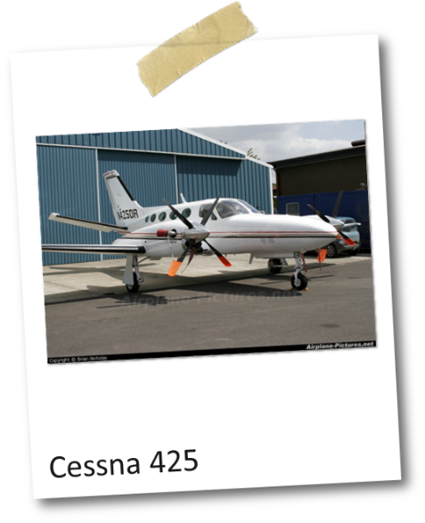

- Notify the WFS Account Executive and / or Operations Specialist ASAP same day.

Actions to be taken to PREVENT a misfuelling.
(Reference: CAOM– Overwing Fuelling Procedures & WFS Procedure GPO-P-Z605)

Mandatory Grade Confirmation

Confirm the grade of fuel with the customer.
All communications regarding overwing fuelling shall include fuel grade.
PRIOR TO FUELLING, the customer shall complete and sign a Fuel Order Form.
- For frequently fuelled aircraft or fleet/airline accounts, a Fuel Order Form does not need to be filled out for every fuelling if the aircraft tail number is verified as being on a Standing Fuel Authorization List. The Standing Fuel Authorization List shall be supported on file by a Fuel Order Form for that specific aircraft or a by a Standing Fuel Authorization for Airlines Form that has been signed by a customer representative and that is dated within the last 12 months.
- Confirm grade by comparing the Fuel Order Form, Standing Fuel Authorization List, nozzle handle colour coding, and Overwing Grade Identification Hose Sleeve with the grade identification at the aircraft fuelling points.
- If no grade identification is present on the aircraft, decals for both grades are to be offered to the customer. If the customer refuses to apply the decals to the aircraft fuelling point(s) then the Fuel Order Form must be signed by the site Operations Supervisor PRIOR TO THE FUELLING.

NEVER place the safety of personnel in jeopardy, whether by threat of fire, explosion or hazardous environmental conditions.

Hijack / Hostage / Terrorist Activity

In the event that a hi-jacking / hostage incident does occur, your major concern should be prevent violence. Experience has shown that violence is very infrequent and that the best way to keep anyone from getting hurt is to avoid trying to be heroic and be fully cooperative with the assailant.

Your safety and that of your staff is far more important than the money or product.

- Remain calm and stay in control. If you get excited the assailant may get excited.
- In case that you are tied up, remain calm and do not make sudden movements.
- If you have any alarms systems, including police 911, DO NOT make any moves to activate them.
- Wait until after the assailant has departed.
- Obey the assailant’s commands and listen carefully to their instructions. Answer questions truthfully.
- Do not try to escape.
- Keep conversation or interaction with the assailant short and smooth.
- Give only the information of what is asked for.
- Do not argue. Cooperate fully with assailant’s demands.
- Do not resist or fight. The money is not worth it. Attacking an armed assailant is not heroic, it’s fool hardy as it may provoke violence.
- Do not make any surprise moves. Tell the assailant what you plan/need to do prior to doing it.
- Look at the assailant(s) if it is safe to do so.
- Do not stare or maintain constant eye contact. (Be observant only).
- Notice details in order to better be able to describe individuals later on to police.
- Clothing colour(s), race, tattoos, name spoken, hair colour, scars, etc.
- Try to determine age, height, weight, and appearance.
- Look for weapons (Type, size, etc.)
- Watch / note if assailant touches anything.
- Never chase or follow an assailant. Important to note the direction the assailant(s) left in and report.
- to the police / authorities when asked.
- Provide as much information as you can remember to the police when asked.
- Time of incident
- Number of assailants involved.
- Description of assailant(s)
- Armed or unarmed.
- Assailant’s direction of travel
- Description of any vehicle used in the crime.
- Do not divulge the details of the incident to anyone except the police.
- Notify your WFS Account Executive and/or Operations Specialist same day.
- Refer any media questions to World Fuel Services Public Affairs department.

NEVER place the safety of personnel in jeopardy, whether by threat of fire, explosion or hazardous environmental conditions.

Aircraft Incident / Aircraft Down

Possible Scenario:
Aircraft is fuelled by refueller on duty, departs the airport and 35 minutes later the refueller on duty is called by Flight Service notifying the operator that the aircraft has crashed…or the aircraft returns to airport with unexplained engine trouble.
Or
Site learns of an aircraft crash or forced landing that “could have been” last fueled at their facility.

Additional information is provided in WFS document GPO-S-Z918
See WFS Technical Bulletin – 2018 – 005

IMMEDIATE Actions:
- Determine when the aircraft in question was last fueled at your site.
- If it was fueled recently at your site, then quarantine (i.e. STOP using) the refueller or cabinet from which the fuel was dispensed.
- Contact your WFS Operations Specialist or Account Executive immediately. Reporting to WFS senior management (as per GPO-SZ918) is the responsibility of the Canadian Operations Manager.
- Identify aircraft fueled before and after the aircraft in question and establish “Safe at Destination” for as many as possible.
- Proceed with filling out the “WFS Aircraft Incident Reporting Form” and send it to your WFS Operations Specialist. This form shall be available locally for immediate use when required. A copy of the form is provided for your reference on the following page.
- Your WFS Operations Specialist will advise as to what actions are required at this point; sampling, documentation review, etc.
- If samples are required, they are to be taken in new unused Texberry cans (10 for Avgas). Sample cans are to be rinsed 3 times prior to filling and witnessed by an airline/customer representative or independent 3rd party who is not a Dealer’s employee. Tag on sample can to indicate source of sample and to be signed by witness. Witness contact information must be obtained and retained by Dealer.
- Do not use the quarantined equipment until authorized by World Fuel Services.

NEVER place the safety of personnel in jeopardy, whether by threat of fire, explosion, or hazardous environmental conditions.

Demonstrations and Riots

- Advise site manager.
- Advise the WFS Account Executive.
- Advise the airport manager, police, FSS, and commissioners.
- Determine the purpose of the riot and demonstration.
- Determine the mood of the participants.
- If possible, identify the organizers of the demonstration.
- Evaluate the risk to employees and the site.
- If required, secure all entry points to the site.
- Advise the police to protect the facility and employees.
- Advise the employees not to become involved or express opinions.
- If possible, photograph the demonstrators and note their activities.
- If demonstrators are on company property:
- Advise them that they are on company property.
- Ask them to leave company property without delay.
- Advise them that any damage to company property will result in court action.
- Request their cooperation and politely ask them to leave the company property.
- DO NOT intervene except at the request of the police.
- If they refuse, advise the police to escort them off the property.
- If the demonstrators want to discuss certain issues with the company:
- Determine the issues they want to discuss.
- Indicate the company’s willingness to discuss the matter.
- Limit the discussion to no more than 5 demonstrators.
- Establish a meeting place away from company property.
- Determine who will attend to represent the company.

NEVER place the safety of personnel in jeopardy, whether by threat of fire, explosion, or hazardous environmental conditions.

Break - Ins

- DO NOT ENTER the area.
- If already in the area, do not touch anything.
- Immediately notify your supervisor.
- Keep all people out of the area.
- If there has been sabotage, and a fuel spill, initiate response plan for spills.
- Try not to alter the crime scene.
- Notify the WFS Account Executive same day

NEVER place the safety of personnel in jeopardy, whether by threat of fire, explosion, or hazardous environmental conditions.

Robbery / Hold Up

- Your safety and that of your staff is far more important than the money or product.
- DO NOT resist.
- DO NOT provoke the robber / follow their instructions.
- Remain calm and alert.
- Note description of robber.
- Observe the departure route, and if vehicle is used, license number and description.
- Notify the police and your supervisor.
- Call medical assistance if needed.
- Remain at the scene until the police arrive.
- Lock the door if possible.
- Complete the police description forms.
- Request witnesses to remain at the scene.
- Write down details of the incident.
- Cooperate with the police.
- Notify the WFS Account Executive same day.

NEVER place the safety of personnel in jeopardy, whether by threat of fire, explosion, or hazardous environmental conditions.

Bomb Threats

- Remain calm.
- If possible, have another person listen in or record the call.
- Notify the Police.
- If possible, have the call traced by the phone company.
- Pay close attention to all the instructions and obtain precise details if possible.
- In consultation with regional management, and police, evaluate the threat, and decide whether the employees should be evacuated.
- If the threat is received in writing:
- Take care in handling the document.
- Place the note in protective envelope and give to your supervisor.
- Make a photocopy but be careful not to remove any fingerprints.
- Turn over original copy to the police.
- Organize a thorough check of the site and surrounding areas.
- Notify the WFS Account Executive same day.

NEVER place the safety of personnel in jeopardy, whether by threat of fire, explosion, or hazardous environmental conditions.

Personal Injury

If able to move:
- Contact supervisor, who will arrange transportation to hospital and for relief of the work still pending.
- When arrived at hospital, ensure that hospital staff is aware that the injury occurred at the workplace.
- Complete all forms required by the hospital staff.
- Coordinate any time off necessary with the company supervisor.
- Complete all forms required by OHS / Worker’s Compensation for the company as soon as comfortably possible.
- If unable to move / regained consciousness shortly after incident:
- Contact emergency services, via 911, and airport Fire Department for immediate first aid, and provide access for emergency personnel.
- Contact supervisor, who will arrange for care of the facility, and relief of work still pending.
- When arrived at hospital, ensure that hospital staff is aware that the injury occurred at the workplace.
- Complete all forms required by the hospital staff.
- Coordinate any time off necessary with the company supervisor.
- Complete all forms required by OHS / Worker’s Compensation for the company as soon as comfortably possible.
- If employee is found unconscious by another employee coming onto shift:
- Contact emergency services, via 911, and airport Fire Department for immediate first aid.
- DO NOT move employee unless:
- You have current First Aid training, or.
- There is a safety concern for the injured employee in their current location.
- Cover employee if temperature is an issue.
- Contact supervisor, who will make contact with the injured employee’s family.
- Provide access for emergency personnel.
- Accompany injured employee to hospital and ensure that hospital staff is aware that the injury occurred at the workplace.
- Complete all forms required by the hospital staff to the best of your ability.
- Contact your WFS Operations Specialist or Account Executive same day if an WFS-owned asset was in any way involved in causing the injury.

NEVER place the safety of personnel in jeopardy, whether by threat of fire, explosion, or hazardous environmental conditions.

Virus Threat

Measures below will help prevent the spread of infections in your workplace, such as colds, the flu, and various viruses and bacteria to protect your customers, contractors and employees.

Prepare

- Make sure your workplaces are clean and hygienic.
- Surfaces (e.g. desks and tables) and objects (e.g. telephones, keyboards) need to be wiped with disinfectant regularly
- Why? Because contamination on surfaces touched by employees and customers is one of the main ways that viruses spread
- Promote regular and thorough handwashing by employees, contractors and customers.
- Put sanitizing hand rub dispensers in prominent places around the workplace. Make sure these dispensers are regularly refilled.
- Display posters promoting handwashing.
- Make sure that staff, contractors and customers have access to places where they can wash their hands with soap.
- Promote good respiratory hygiene in the workplace.
- Display posters promoting respiratory hygiene. Combine this with other communication measures such as offering guidance from occupational health and safety officers, briefing at meetings and information on the intranet etc.
- Ensure that face masks and / or paper tissues are available at your workplaces, for those who develop a runny nose or cough at work, along with closed bins for hygienically disposing of.

Prevention

- Advise contractors to consult the visitor logbook which will contain a infectious disease guidelines and infection prevention guidelines.
- Brief your employees, and contractors that if an infection starts spreading in your
- community anyone with even a mild cough or low-grade fever (37.3 C or more) needs to stay at
- home.
- Keep Staffing levels to a minimum and shift meeting to a minimum
- Maintain distance when taking fuel orders and do not make contact with any crew members when fuelling. Verbal commands for fuelling are acceptable, just repeat the orders for confirmation.
- Do not let any anyone near you work area or in the cab of your truck.
- Nitrile gloves shall be disposed of after each fuelling and shall be place in the marked container when returning to main building.
- Wash and sanitize after each fuelling.
- The Waterloo Wellington Flight Centre has a computerized and text-based dispatch system so no line crew or pilot needs to be in contact with the fueller for any reason. Contact dispatch using the company phone to resolve any issues.

Monitor
- Fuelling Oversight/Safety will monitor fuellings to make sure that policy is being followed.
- Identify any new areas of concern and take steps to prevent the spread of any infection and update and communicate new policies to the employees.
- Ensure that workers can raise safety concerns at any time.
- Continue to assess the risk of continuing operations on a daily basis. As flight operations increase over time the risk of contact increases, flare up of infections in certain areas could increase dramatically.

NEVER place the safety of personnel in jeopardy, whether by threat of fire, explosion, or hazardous environmental conditions.

Natural Phenomena

(Guidance: Fire Threat, Hurricane, Tornado, Flood, Severe Cold Weather, Wind Storm, Lightning Strike, Power Outage) (Choose natural phenomena that would be most likely to impact your airport)

- Contact National Weather Office for possible adverse weather condition or other natural phenomena.
- Notify all employees and the WFS Account Executive and/or Operations Specialist of possible adverse weather or other natural phenomena.
- Designate one employee to secure tank farm (i.e.: remove all loose objects such as spill drums, fire extinguishers, slop drums).
- Have another employee establish contact with the authorized person, and emergency personal. (i.e.: Ambulance company.)
- Perform tank dips and check piezometer wells while securing tank farm.
- Have all employees meet at Muster Point (Identify the location of the muster area on the planned evacuation routes outlined in the response plan).
- Designate an employee to conduct a head count.
- Mobiles must be secured and moved to a safe place, and place logbooks on board.
- Have Auxiliary generator set up if available / needed. (Airport / Associate Maintenance Staff).
- See the Airport emergency procedures manual for further information and contact numbers. Available through the dealer or authorized person. (Section listed as Emergency telephone numbers in Airport Emergency Manual.)

Suspicious packages

Suspicious packages could be delivered to your home or workplace, so it is good practice to be vigilant and aware of what to do. You know what kind of mail and packages you usually receive. Look for things that are out of the ordinary, such as unexpected mail from a foreign country. The following might help in identifying a suspicious package:

• Unfamiliar return address or none at all
• Strange odour or noise
• Protruding wires
• Excessive postage
• Misspelled words
• Addressed to a business title only (e.g. President)
• Restrictive markings (e.g. Do not X-ray)
• Badly typed or written
• Excessive wrapping, tape or string
• Oily stains, discolouration or crystallization on wrapping
• Leaking

The contents of a letter or package may cause concern if:
• You see powder or a liquid.
• It contains a threatening note.
• It contains an object that you did not expect to receive or cannot identify.

If you are worried about a package or letter you have received:
• Do not handle, shake, smell or taste it.
• Leave the letter or package where it is.
• Get everyone out of the room and close the door.
• Call Airport Security (or the emergency response number in your area, if applicable)
• Wash your hands with soap and water.
• If applicable, alert building security or the superintendent.
• Wait in a safe place until the police or fire response teams arrive.

If you have opened a suspicious package:
• Leave the package where it is.
• Remove any clothing that has powder or liquid on it and seal it in a plastic bag.
• Get everyone out of the room and close the door.
• Wash your hands or shower with soap and water.
• Call Airport Security (or the emergency response number in your area, if applicable)
• If applicable, alert building security or the superintendent.
• Wait in a safe place until the police or firefighters arrive.

The police, other emergency workers and public health authorities will give advice about what to do next.

Weather Warnings – Lightning

- If at any time lighting is in the area the Region of Waterloo Airport will advise all tenants of the danger.

- They will activate the lighting warning system (THOR system) which is indicated by a flashing red light which is located on the north side of the main terminal wall.

- They will also email to confirm that there is lighting in the area.

- All ramp operations including fuelling will stop when the red light is on.

Emergency Phone List

AIRPORT

Airport Operations 1-519-648-3370
Airport Fire Hall 1-519-648-2256 Emergency EXT# 8511
Security 1-519-648-2256 Emergency EXT# 8520
Flight Service Station / Tower 1-519-648-3055

SUMMIT FUEL SERVICES

Justin Labelle 519-648-2213 ext. 109

Brian Finnerty 1-519-572-2684 Cell

WOLRD FUEL SERVICES

Elizabeth Tessier- Account Executive WFS 514-968-7495
etessier@wfscorp.com
Paul Frenette - Operations Specialist WFS 902-580-0055
PFrenette@wfscorp.com

24 Hr. Emergency Response Contact Number 1-800-608-0298
When to call the 24 Hr. Emergency Response Number
- When you need to report to that a serious incident has occurred at your site and you cannot reach your Account Executive or Facility Specialist or any internal Summit contact.
- When you are unclear about how to proceed in responding to a local site incident or emergency situation.

